**PROJECT REPORT**

**PROJECT PROFILE**

**Project Name:-** Web Designing Company Template

**Platform :-** Windows

**Description:-**

**Front End Language:-** HTML,PHP,CSS

**Back End Language:-** MySQL 5.0.10

**Type Of Application:-** Web application

**Web Server:-** Apache, Nginx

**Web Browser:-** Opera, Google Chrome, Safari

**Develop By :-** Deep Goriya

**System study**

* **System Study:**
* **Existing System:**

**Study of current system**

* In the present web system is for shopping site and different

types of products and many categories to attract the people.

**Problems and weakness of the system.**

* This website cannot run without internet.
* Only single user can accessible.
* This website is quite difficult to use.
* This website is run in limited devices.
* **Proposed System:**
* In this system different modules are available which all uses are

as an activity in this website project or system, these modules

are as follows.

* Login
* Registration
* Category
* Products
* Deals
* Add to cart
* Wish list
* Payment
* Delivery details
* About us
* **Aim and objective of the Proposed System:**
* reasonable rate
* User can easily find what he/she need.
* All user can easily Shopping in our website.
* **Website feature:**
* It’s show’s variety of categories.
* List of low to high price range in any products.
* Easy to find what you actually need.
* If you buy any product from our website will be given in just 24 hours.
* Subscription plan/Prime membership.
* If you buy our subscription plane we give special discount, and special deal and special offers and no delivery charges many more.
* Get a refund when packages are late.
* You can buy any thing just scrolling the fingers.
* Use your camera to search for products.
* **Feasibility Study:**
* **Operational Feasibility:** The website working is quite easy to use and learn due to its simple but attractive interface. User requires no special training for operating the website.
* **Technical Feasibility:** The technical requirement for the website is economic and it does not use any other additional hardware and Software, and this website run in most of server browser. The system can be expanded by adding new feature if necessary in future.
* **Economical Feasibility:** The website being developed is economic with respect to user point of view. The result obtained contains minimum errors and are highly accurate as the data is required.

**SYSTEM ANALYSIS**

* **System analysis:**

During implementation the following tools have been used to develop the website and perform necessary testing.

|  |  |
| --- | --- |
| **Google Chrome** | **Safari** |
| Internet connection is very important. | Internet connection is very important. |
| To use chrome browser in windows, you’ll need: windows 7. | To use safari browser in your device you must have apple device. |
|  |  |

* **System Modules**
* **Admin Modules**

1. Login
2. Manage login access
3. Manage category
4. Manage order
5. Manage user Details
6. Manage Account Details
7. Manage Feedback

* **User Modules**

1. Registration
2. Login
3. Manage Details
4. Add To Cart
5. Wishlist
6. Payment Details
7. Order Details

**DIAGRAMS**

**Admin Side Diagram**

* **Module Hierarchies**

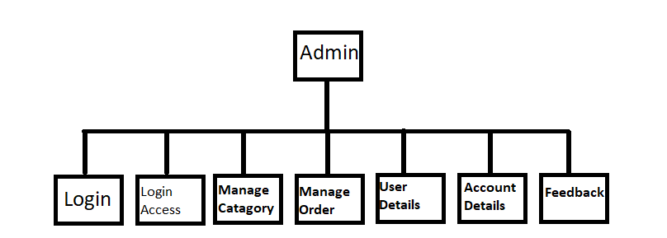

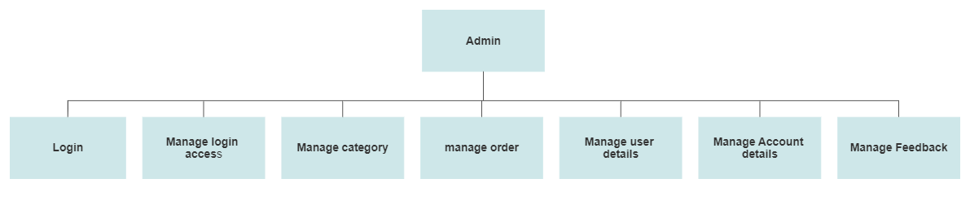

* **Activity diagram**

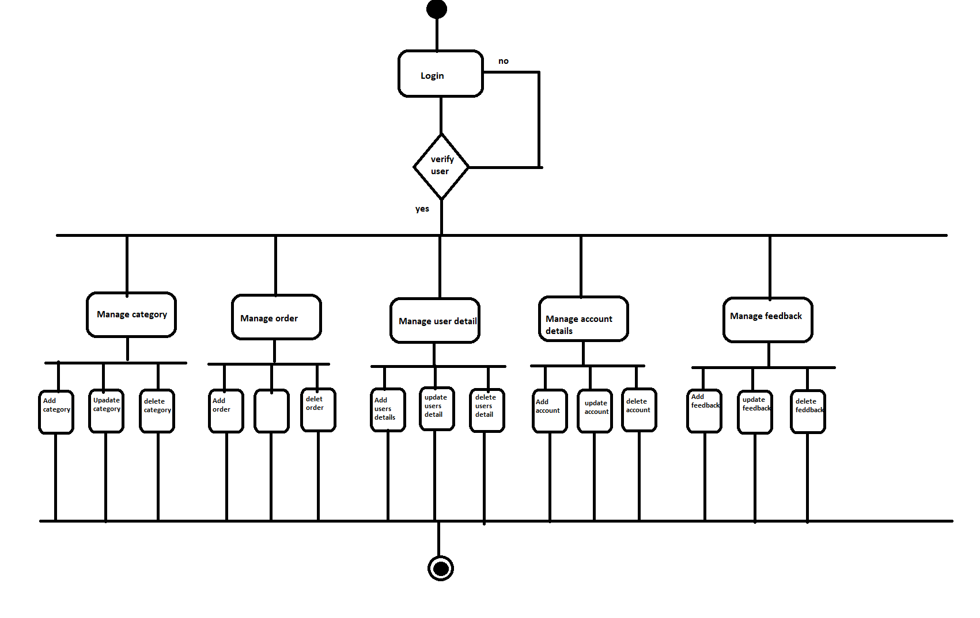

* **Usecase diagram:**

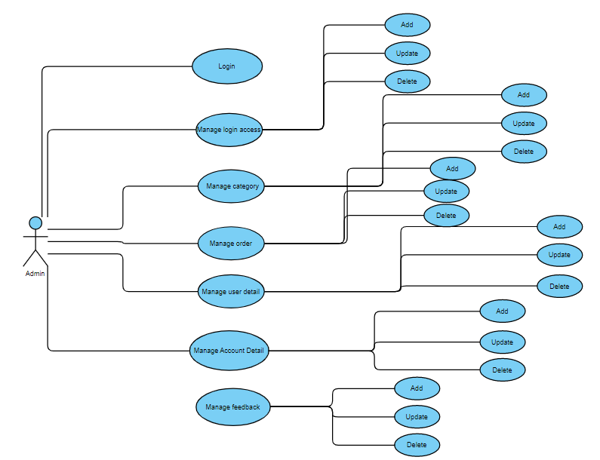

**USER SIDE DIAGRAMS**

* **Module Hierarchies**

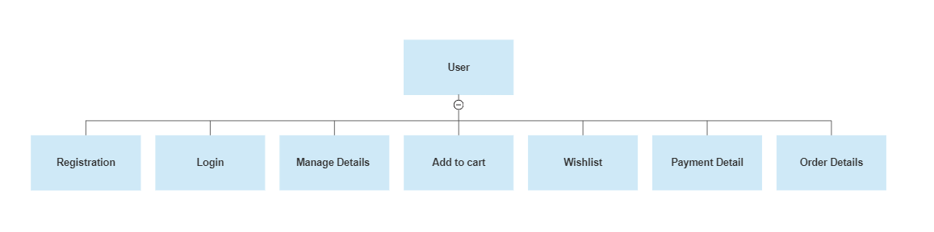

* **Activity diagram**

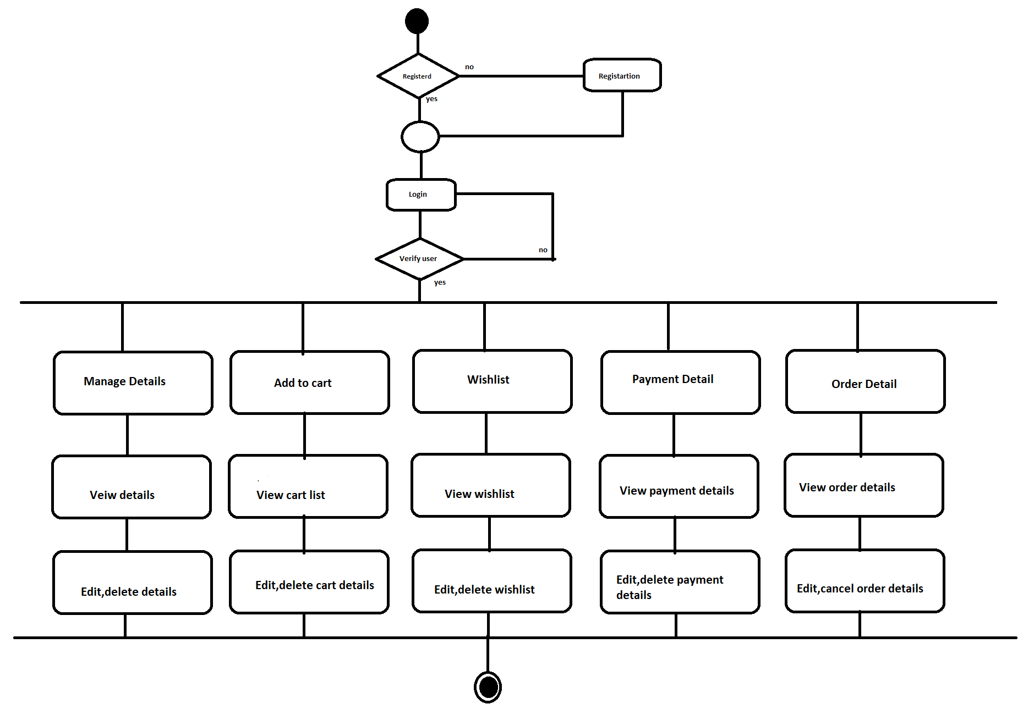

* **Usecase diagram:**

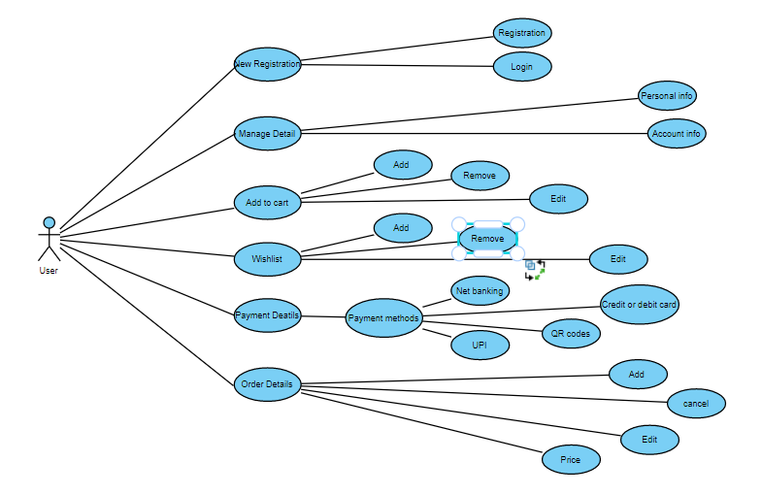

**SYSTEM DESIGN**

**DATA DICTIONARY**

* **Data Dictionary:**
* **Login:**

|  |  |  |  |
| --- | --- | --- | --- |
| **Column Name** | **Data Type** | **Constraint** | **Description** |
| Login ID | Integer (15) | Primary key | All login id is different |
| Password | Varchar (6) | Not null | Minimum 6 digit must be added |

* **Categories:**

|  |  |  |  |
| --- | --- | --- | --- |
| **Column Name** | **Data Type** | **Constraint** | **Description** |
| Category ID | Integer | Primary key | All category id is different |
| Category name | Varchar  (50) | Not null | This filed shows the category name |
| Category types | Varchar  (10) | Not null | This filed shows types of categories |

* **Products:**

|  |  |  |  |
| --- | --- | --- | --- |
| **Column Name** | **Data Type** | **Constraint** | **Description** |
| Product ID | Integer | Primary key | All product id is different |
| Product name | Varchar (30) | Not null | It’s shows name of the of product |
| Product type | Varchar (30) | Not null | It’s shows types of the of product |

* **Payment:**

|  |  |  |  |
| --- | --- | --- | --- |
| **Column Name** | **Data Type** | **Constraint** | **Description** |
| Payment ID | Integer | Primary key | All payment id is different |
| Payment details | Varchar (12) | Not null | It’s shows details of the of payment |
| Payment method | Varchar (12) | Not null | It’s shows method of the of payment |

* **User account data:**

|  |  |  |  |
| --- | --- | --- | --- |
| **Column Name** | **Data Type** | **Constraint** | **Description** |
| User ID | Integer (12) | Primary key | Every user id is different |
| User name | Varchar (12) | Not null | It’s shows name of the of user |
| Password | Varchar (12) | Not null | Minimum 6 digit must be added |
| Mobile no | Integer (10) | Not null | It’s shows mobile number of the of user |
| Wishlist | Varchar (20) |  | It’s shows Wishlist of the of user |
| Delivery details | Varchar (20) | Not null | If you buy anything in our website, you must add your delivery address |
| About website | Varchar (300) | Not null | It’s shows information, terms and condition, deals, offers and many more |